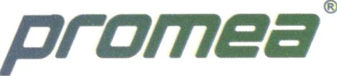

**Date** : 02/03/2024

**AUTHORIZATION LETTER**

From,

Promea Therapeutics ltd,

Hyderabad

Subject: Authorization of rubber stamp making

Sir/Madam,

Please be informed that Sri Ram Charan (Territory Sales Manager) Authorized employee of our company , will be reaching out to you on my company's behalf for the purpose of round rubber stamp making.

Please proceed as per our requirement and do the needful

Thanks & Regards





Office & Factory: Plot No: M4, Medical Device Park, Sultanpur (V), Ameenpur (M), Sangareddy (Dist.), Telangana — 502 319 GSTIN: 36AAJC3437C 1ZK, CIN No.: U24304TG2017PTC118617